Phase 6 Shell Script Info

# Basics

There are two shell scripts, the daily.sh and weekly.sh scripts. They are both located in the SQA-Back-End/test folder, and are bash scripts that were tested using the Windows System for Linux. The front end may need to be remade – this can be done using the Makefile in SQA-Back-End/SQA-Front-End. The .jar file may also need to be recreated, or the right java file may need to be installed. It was built using jdk14, and can be rebuilt from IntelliJ IDEA, or a version of jdk14 can be found online (pre-release).

The daily shell script takes test input from a day#/test folder using files from the day#/in folder and outputs new item and user files to the day#/out folder, as well as a merged transaction list. Terminal outputs for each front-end test run can be found in the day#/termout folder, and the backend terminal output can also be found there.

The weekly shell script takes input from the day1 folder up to the day5 folder. It starts with input from the day1/in folder, copies output from that day into the next day’s in folder, and re-runs the script continuously. Output can be found in each folder for each individual daily run as the daily script still logs output, and final item files and user files can be found in the weeklyOut folder.

The shell scripts may require a line ending switch from CRLF to LF. The same goes for the terminal input files as well as some of the other test files found. GitHub doesn’t accept line ending changes very nicely, so the .zip file on Blackboard is a better solution to running this program.

You can also use this script to change line endings (change the file name to the name you want):   
awk '{ sub("\r$", ""); print }' daily.sh > daily2.sh

mv daily2.sh daily.sh

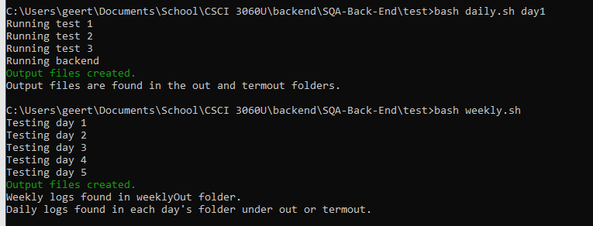

Figure 1: Running the daily and weekly scripts from cmd

# Sample input and output

## Day 1 – Terminal Inputs (test/day1/test)

|  |  |
| --- | --- |
| Test Session | Test Input |
| Session 1 | create  johndoe  password  FS  exit |
| Session 2 | LOGIN  sellingboy  isellthings  advertise  calculator  19.99  27  advertise  nintendo switch  450  19  logout  exit |
| Session 3 | login  buyingman  ibuythings  bid  apple  0  yes  7.99  logout  exit |

## Day 1 – Transaction Files (Individual and Merged)

|  |  |
| --- | --- |
| Test Session | Test Input |
| Session 1 | 01 johndoe password FS 000000.00 |
| Session 2 | 03 calculator sellingboy 027 019.99  03 nintendo switch sellingboy 019 450.00  00 sellingboy SS 555555.56 |
| Session 3 | 04 apple sellingboy buyingman 007.99  00 buyingman BS 999999.00 |
| Merged | 01 johndoe password FS 000000.00  03 calculator sellingboy 027 019.99  03 nintendo switch sellingboy 019 450.00  00 sellingboy SS 555555.56  04 apple sellingboy buyingman 007.99  00 buyingman BS 999999.00 |

## Weekly – Final File Output

|  |  |
| --- | --- |
| File | Output |
| Available Items File | 1 test item AnotherUser mr.runescapeman 084 102.99  2 apple sellingboy buyingman 076 007.99  7 nintendo switch test123 geerthan 017 500.00  4 nintendo switch sellingboy 041 089.00  5 calculator sellingboy 024 019.99  6 nintendo switch sellingboy 016 450.00  7 nintendo switch test123 geerthan 017 500.00  8 dragon scimitar mr.runescapeman 006 015.99  9 security analysis test123 geerthan 013 018.00  10 dnd gajan 010 015.99 |
| Current User Accounts File | mr.runescapeman buyinggf20k FS 000000.44  heckingcoolman chimmychonga BS 001000.55  adminboy AdPass123 AA 999999.00  test123 secret FS 223169.22  buyingman ibuythings BS 999999.00  sellingboy isellthings SS 555555.55  babyyoda lilcuteguy FS 000000.66  paul new FS 000000.00  temp temp -- 000000.00  yo hello DS 000000.00  test fail FS 000100.00  johndoe password FS 000000.00  bigboidaddydude password FS 000000.00  gajan secret SS 000000.00  geerthan password BS 000000.00  paul44 password FS 000000.00 |